Approach
Here the approach is very simple we basically must create a DP to store the states. For any DP problem all follow the same rule that we should Memoize the truth value of (n,m) then we need the values of (n−1,m) or (n,m−1) or (n−1,m−1) this would be the whole point of DP.
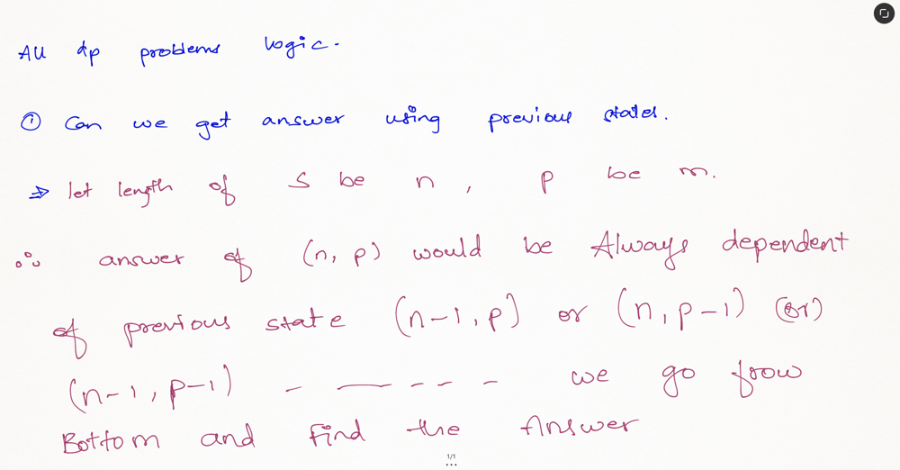
The example of mississippi is taken and the DP table is depicted below and the explanation is provided down.
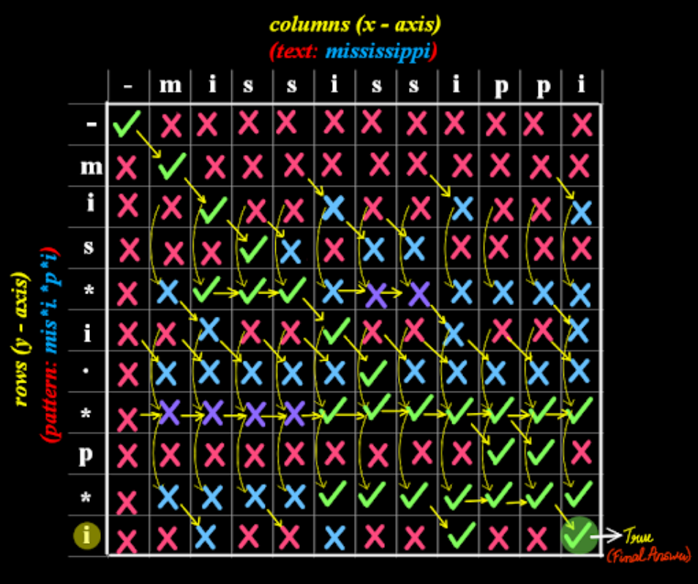
Here we basically broke the entire one into three cases as shown in the below picture. Now we procced based on the below three cases and construct our DP table and thus we finally obtain our answer.
